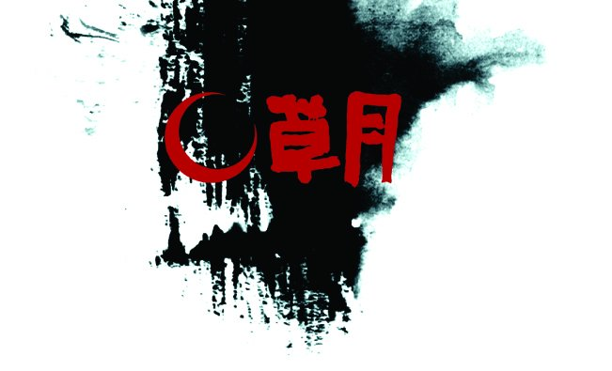

REGISTRATION FORM
Yes, I sign me as member of Sogetsu Branch Nederland
(55,00 euro year).

Family name: First name:

Adress/postal code: Place:

Country: Date of birth:
Phone/mobile : E-Mail:

Student of: Certificate:

Sogetsu number:

Teache : Grade:

STA nr.:

In accordance with privacy laws (General Data Protection Regulation)
Yes/No to agree to provide your personal information to other members for ikebana
purposes only.
Yes/No to agree to post pictures of yourself in our Sogetsu Magazine, website and
social media.
Yes/No to agree to post pictures of your arrangements in our Sogetsu Magazine,
website and social media.
Yes/No to agree to make use of pictures made by you in our Sogetsu Magazine,
website and social media.
Yes/No to agree by forwarding pictures made by you at the request of third parties.

Signature : Date

Mail this form to: secretariaat@sogetsubranchnederland.nl

Payment to treasure Rianne Machielse
IBAN NL82 INGB 0002 2784 32 t.n.v. Sogetsu Branch Nederland,
4724 DB, Wouw
BIC INGBNL2A (for transfer from abroad)

